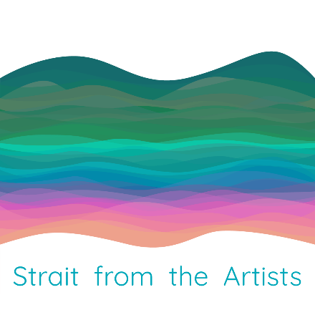**Strait from the Artists Studio Tour Application  
From: Strait from the Artists Planning Team  
Application Deadline Date: July 30, 2024  
Event Dates: Saturday, November 9 and Sunday, November 10, 2024  
Time: 10:00 AM – 3:00 PM**

**Location: Your studio* or a venue featuring multiple artists.**

**From the snow to the shore,** **engage directly with the artists and the spaces that they create in.**

**Information and Guidelines**

Strait from the Artists Studio Tour is a self-guided, free and open to the public, tour of multiple artist studios and exhibition spaces from along the inspiring Strait of Juan de Fuca, which includes the Sequim and Port Angeles Cultural Corridors. Attendees can visit, view, and learn directly from the artists about their diverse creative processes and the imaginative community-minded efforts of their work. Strait from the Artists Studio Tour is committed to the business of art and how creative enterprise is a respectable pursuit that empowers individuals, validates collaboration, and engages whole communities together.

Strait from the Artists Studio Tour is organized by local, Olympic Peninsula art businesses, arts advocates, and educators dedicated to encouraging education, positive professionalism, and creating inclusive and innovative opportunities. Creating cultural vitality is financially sound for a population and improves the quality of life in a community. A thriving arts community benefits all businesses that in turn support artists, educators, and cultural institutions.

**Artist Selection Process:** This is an invitational, juried show. We emphasize original, high quality, artisan work and wares **and the opportunity for the public to engage directly with the artists and the spaces that they create in.** Applications will only be considered from artists who personally handcraft the items they sell and who will be present in their studio or a shared space with other artists at a studio during the event hours of operation. Reproductions from your original works or licensed items will be considered. Commercial, imported or consignment items are not allowed. The artist must provide proof of license in order to use trademarked images in their products. Your application will not be juried until the application, images, Hold Harmless Agreement, and application fee have been received. The application and images may be emailed and the Hold Harmless Agreement and application fee must be mailed.

**Strait from the Artists** **Studio Tour will provide the following:** A webpage dedicated to each artist who is part of the Strait from the Artists Studio Tour website, StraitfromtheArtists.com. This will include a brief description, image or video, your name and business name. Each studio location along with the artists at that location will be listed on the website. There will be no selling directly from StraitfromtheArtists.com. Please provide reciprocal links from your website and online presence to StraitfromtheArtists.com Along with specific branded merch, we will provide branded marketing files that you can use online and / or print to support the collaborative marketing efforts we are doing together.

**\*Artists and Studio Requirements:**

Each artist must have a current business license.

Studio Host locations must have liability insurance.

A “hold harmless” waiver signed by each artist.

Artists are asked to help collaboratively promote Strait from the Artists Studio Tour both online and with Strait from the Artists provided cooperative promotional materials. Artists will collectively spread the word about all the artists, including our website, on the Strait from the Artists Studio Tour on social media. Artists will be provided a list of links and hashtags (#) to use.   
Comply with local pandemic precautions, if necessary, at the time. Artist applications due July 30, 2024.

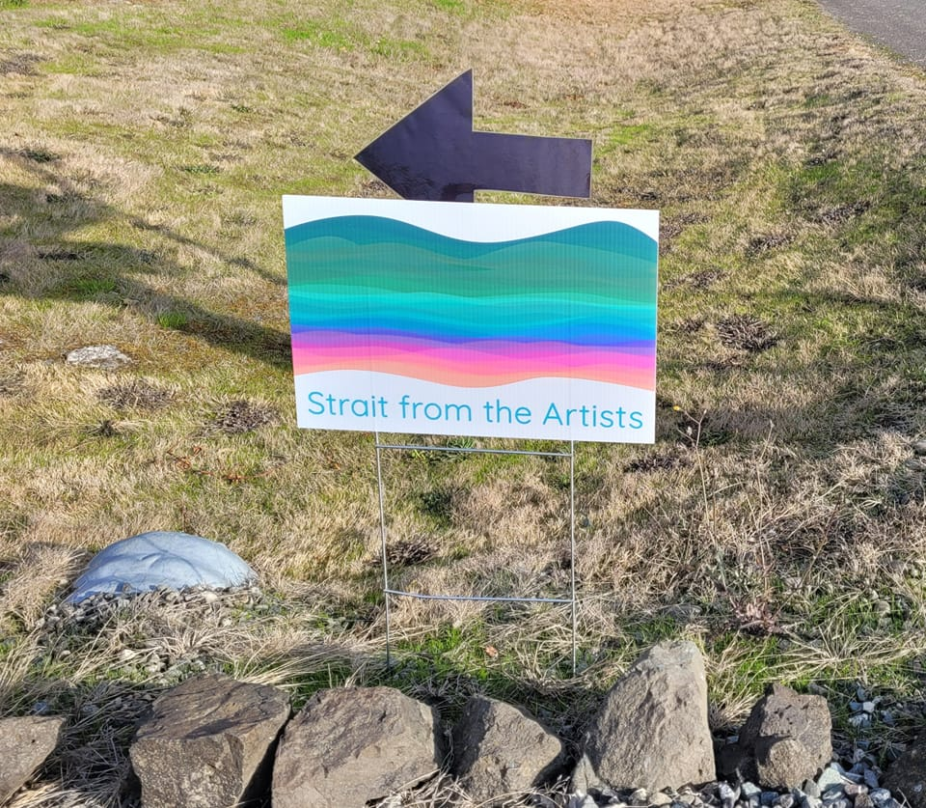

**Your Strait from the Artists Planning Team thanks you and looking forward to working together!**

[**https://straitfromtheartists.com**](https://straitfromtheartists.com)

[**https://www.facebook.com/StraitfromtheArtists**](https://www.facebook.com/StraitfromtheArtists)

**Strait from the Artists Studio Tour Application  
Strait from the Artists Planning Team  
Application Deadline Date: July 30, 2024  
Event Dates: Saturday, November 9 and Sunday, November 10, 2024  
Time: 10:00 AM – 3:00 PM**

**Location: Your studio* or a venue featuring multiple artists.**

**Please fill out this form by typing directly in this DOC file for ease of use of the important content for marketing and website building. Please do not fill it out with handwriting. Please save the file with your name in the title of the file. Thank you very much!**

**Contact and Connections Information:**

Business Name: ____________________________________________________

Artist Contact Name: ___________________________________________________

Address: __________________________________________________________

City: ___________________________________State: ­­­­____ Postal Code: ___________

Best Contact Phone: __________________ Other Phone: ______________________

Email: _________________________

Website or links to your online presence to be used for the studio tour website StraitfromtheArtists.com: Your Website: ______________________________   
Facebook: ___________________ Instagram: __________________ Twitter: _____________

**Washington State UBI#:** _______________________ If you do not have a number / business license, please attach a statement explaining why not. You must be registered with the State of Washington. If need to get your license, apply at the Washington State Department of Revenue (https://dor.wa.gov/open-business/apply-business-license) for more information.

**Studio Location Address:** ______________________________________________________

Artists must reside in the North Olympic Peninsula in either Clallam or Jefferson County. This can be your own studio or a shared space with other artists at a studio.

Do you want to host other artists and need help connecting with them? Yes ___ No___

Is your studio Americans with Disabilities Act (ADA) Accessible? Yes ___ No___

**Liability Insurance:** Yes ___ No___ If you do not have insurance, we encourage you to check out ACT insurance (www.actinsurance.com) for a one time show insurance.

**Artwork requirements, image files, artist information, and other Images for jurying and marketing:**

Please list and describe all artwork and products to be sold:

__________________________________________________________________

___________________________________________________________________

___________________________________________________________________

The website will have creative categories and mediums listed, please help us guide patrons by providing classifications of your artwork. For example, fiber art, jewelry, ceramics, assemblage, and so forth.

All work must be your original art or a derivation of your original art.

Each artist must take full responsibility that their art is adequately represented.

If you make products using images that are not your own, such as Seahawks or Disney, you must be able to provide proof of license in order to use trademarked images in your products.

Submit at least three but not more than 6 digital images (via email) of your artwork, products, and a photo of your studio and / or you in the creative process.

High resolution images to be used for print and online advertising and promotion. Please include the artists name and artwork title in the file name. Images will be used on the Strait from the Artists Studio Tour website.

Link to your online presence that will be used on the Strait from the Artists Studio Tour website.

By July 30 2024, please email a description of your products and/or business to be used on the Strait from the Artists Studio Tour website and other marketing for the event. Supply a short description (300 to 500 characters) of your products or art that will be available on Strait from the Artists Studio Tour with your image to let people know about you. Additional text about you and your artwork are welcome, we want the short description for the top of the webpage as a quick enticement.

We will access your website and/or online presence to be able to review your business for jury purposes.

We have the right to refuse any artist.

**Hours of Operation:** For 2024, all studios must be open for business the Second Weekend in November which is Saturday, November 9 and Sunday, November 10 from 10:00 AM to 3:00 PM both days.

**Studio Map:** The Studio Tour Website, straitfromtheartists.com, will provide the address to your studio location with a map. This access to your studio location will be temporary and indicate it is only open during the studio tour time frame. We understand that most studios are private and visitors are welcome only during special art related events.

**Fee:** Participation Payment of $40.00 per artist for your contribution for collaborative provided promotional materials costs, this includes website listing.

**Acceptance Notification:** Artist notifications of acceptance will be sent as soon as your application has been through the jury/application review process. We aim to inform artists before August 1. You will receive additional information after September 1, 2024. If you are not included in the notification of acceptance, your payment will be return.

**Delivery of Application:**

Please email the completed Strait from the Artists (SFTA) application as a .doc or .docx file (Microsoft Word or Google Doc) with image files attached to renne@uniqueasyou.com

If you cannot provide a .doc or .docx file, please place all text in an email.

Please mail the printed and signed Good Faith Pledge and Hold Harmless Waiver with $40.00 Fee payable to “SFTA / unique as you” in the form of check or money order to Renne Emiko Brock at P.O. Box 2633, Sequim WA 98382 by July 30, 2024.

**Good Faith Pledge and Hold Harmless Waiver for Strait from the Artists Studio Tour**

l, the Undersigned agree to adhere at all times to all rules, regulations and policies of the Strait from the Artists Studio Tour. The undersigned hereby releases the Strait from the Artists Studio Tour during this event on November 9 and 10, 2024.

l, the Undersigned certify that I will only sell the type of items presented in this application.

l, the Undersigned do hereby agree to release, relieve, discharge, indemnify, defend and hold harmless the Strait from the Artists Studio Tour from all claims, losses, suits, damages, judgments, expenses, costs and charges of every kind, including court costs and attorney's fees, arising out of acts of negligence of undersigned, his agents or employees. This paragraph shall survive termination of this Agreement.

l, the Undersigned fully understand that the terms of the Full Release shall serve as a Full Release and Full Assumption of risks for myself, my heirs, executors and administrators and for all persons authorized by me as part of the Event.

l, the Undersigned fully understand that having liability insurance at your studio location protects you, your patrons, and the partnership of artists on this tour.

l, the Undersigned understand that I am solely responsible for collecting and paying sales taxes on my goods and services for any and all business licenses necessary for doing business in the State of Washington.

l, the Undersigned understand that I am solely responsible for the delivery or shipping of my goods and services to the customers.

l, the Undersigned understand that I am to comply with local pandemic precautions, if necessary, at the time.

l, the undersigned have read the Full Release form, understand its terms and acknowledge that without my acceptance, I will not be permitted to participate in the Event.

l, the Undersigned hereby accept all of the terms of the Full Release of Liability as evidenced by my signature below.

________________________________ ______________________

Artist Name (please print) Signature

___________ ___________________________________________

Date Business Name